2 Minute Form
Trip Name: Arkles Bay to Dacre Cottage
Check-in Name and Phone:
Date: Branch:
Leaders
Cell Phone Number
VHF Call Sign &/or Vessel Name
Vehicle make, model, registration, colour
General Plan
Note: If plan changes, you must notify your Check-in person.
Latest Time Off the Water |  |  |  |  | TMP/ AMP used²⁰
Tide/ Forecast Lake Level | Low |  |  | High | Other
Communications Carried²¹
Communications | We will be communicating as a group on VHF Channel _____
Equipment Carried
Trip Report
(Use other side if more space required)

Activity | Club Trip | Centre | Auckland | Location |  |  | Auckland |  | Difficulty¹ |  |  | Beginners
Activity Description | Paddle from Arkles Bay, go up the Weiti Stream for as far as you wish, then head back to Dacre Cottage, Karepiro Bay. Return to Arkles Bay. |  |  |  | Leader qualification req.² |  | Trip Leader
Get in Location | Arkles Bay |  |  |  | Chart |  | 532 |  | Distance |  |  | 5-10km depending on how far up the Weiti Stream you go.
Get out Location | Arkles Bay |  |  |  | Coastguard Channel |  | 80, 82 |  | Nowcasting |  |  | 21
Emergency get out ⁵ | Any beaches between Arkles Bay and Karepiro Bay. |  |  |  | Emergency / Coastguard Station |  | Auckland |  | Phone |  |  | *500  09 303 4303
 |  |  |  |  | Drinking Water⁶ | Tank water at Dacre Cottage |  | Toilets⁷ |  |  | Flush toilets at Arkles Bay; long drop at Dacre Cottage
Emergency Response | Refer Emergency Response Booklet |  |  |  |  |  |  | Parking⁸ |  |  | Arkles Bay
Specific Equipment Required⁹ | None |  |  |  | Working Communications equipment in this area¹⁰ | Cell phone  Sat phone |  |  |  | Mountain Radio |  |  | PLB  VHF
Other resources  and notes¹¹ | This area is a marine reserve and no fishing is allowed.  This is a lovely beginner’s trip with the option of going up Weiti River as far as you wish. Sheltered from the N.  Pete Townend is the man to see if you would like to stay in the barn, and/or access the cottage. |  |  |  | Weather Parameters¹² | Beginners Wind under 15 knots, no significant surf or swell  Intermediate Wind under 25 knots, and surf or swell less than 1.5 metres  Advanced Any condition that is suitable for the trip's aims
Previous incidents - unknown

Safety Management¹⁴
Hazard |  | Significant? |  | Management Strategy¹⁵ |  |  |  | Hazard | Significant? | Management Strategy¹⁵
Cold Water |  | Yes |  | Carry spare dry clothes and shelter |  |  |  | Deep Water | Yes | Correctly fit PFDs
Medical Conditions |  | Yes |  | - Leader has first aid qualification  - Ask customers about medical conditions |  |  |  | Bad Weather | Yes | Understand weather forecasts.  Have back up plans or pull out if necessary
Capsizing |  | Yes |  | - Correctly fit PFDs  - Skills at performing rescues. |  |  |  | Heat / Sun | Yes | - Protective Clothing (worn)  - Sun Screen  - Plenty of drinks  - Sunglasses
Panic |  | Yes |  | Ensure conditions match level  of skills |  |  |  | Obstacles | Yes | Awareness of reefs, navigational hazards, nets
Stranding on sand banks |  | No |  | Stranding – there is an extensive shallow sandy area at the entrance to the Weiti River as the tide drops – go wide, or be prepared to walk. |  |  |  | Other Vessels | Yes | - Understand the “rules of the sea”  - “Be seen” – Have two of the following; flag, brightly coloured kayak, brightly coloured PFD or hat. At night: an all round white light & a powerful torch.
Stingrays |  | Yes |  | If wading in the water keep on the lookout for stingrays as there are large numbers in the area. If the water is not clear, shuffle your feet as you walk. |  |  |  | Channel crossing | Yes – M | Take care at the mouth of the Weiti as you are crossing a boating channel – keep a lookout for approaching vessels.
Written up by: | Larraine Williams |  | Approved By: |  | Russell Williams | Signed: | RW |  | Date: | 23 December 2013 | Review in: | 12 months from date of approval

Other Notes:
This trip is very tide dependant - the tide goes out a long way here so you need to be landing and launching mid to high tide.
Dacre Cottage is an historic cottage with an interesting history. More information http://www.dacre.org.nz/
Any labour you are willing to offer is always gratefully accepted – tree planting, weeding, lawn mowing etc – see Pete Townend.
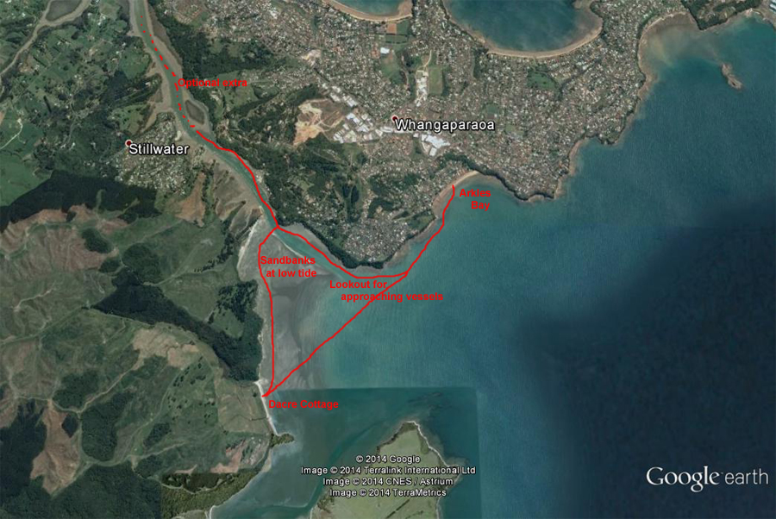
Activity Equipment Check list
Equipment List
- Helmet (rivers & surf) Group Gear
❑ Beanie / hat  Split paddles
❑ Thermals  Repair kit
❑ Paddle Jacket  Fire lighting
❑ PFD  Cooker/thermos
❑ Spray deck  Spare thermals
❑ Booties  Tow system
❑ Water & food  1st Aid Kit
❑ Kayak & paddle  Flares
Group - Oceans & Lakes  Compass
❑ Pumps & Paddle Floats  Charts / Maps
Group - River  GPS (optional)
❑ Throw ropes  Knife (cut rope)
❑ Pin kit & saw  Emergency Shelter

In case of emergency: Dial 111, Mayday :VHF Channel 16

Kayaking Check list

❑ Trip plan
❑ Latest weather forecast
❑ Conditions match skills?
❑ Hyperthermia (hot) &
Hypothermia (cold)
❑ On & off water safety
❑ Environmental concerns
❑ Emergency Procedures include emergency get out.
❑ Working communication devices
e.g. VHF radio, mobile phones, PLB
❑ Specific safety issues for this trip
❑ Participant list
❑ Any medical conditions
❑ All participants keen to proceed?

❑ Trip Plan/ 2-minute form lodged with Ops. Manager

Appropriate wind conditions to run trips:
Novice - no significant surf or swell, wind under 15knots
Intermediate- surf or ocean swells less than 1.5 metre or wind under 25 knots.
Advanced- any condition that is suitable to the trips aims

At conclusion of trip:
Contact check in person
Group Debrief.

Check in Person Ph:
__________________ Mobile
__________________ Work
__________________ Home

Activity Document Cover Sheet

Activity:
Date of Activity:

Activity reports. Is all relevant information present:
– Approved Trip Management Plan (TMP)/ 2 minute form
– Club Trip Participant Sheet
– Weather forecast
– Activity Check List
– Trip report (May be on the 2 minute form)
– Accident / incident reports
Leaders Signature:
Date:

